

LICENSURE EXAMINATION FOR PROFESSIONAL TEACHERS
SEPTEMBER 20, 2026

GURONG PINOY: PROFESSIONAL EDUCATION REVIEWER
(Session 12: May 25, 2026)

1. It is the passing of culture from one generation to another.
- Acculturation
- Enculturation
- Cultural Relativity
- Value Formation

Note: Cultural Learning

ENCULTURATION: process by which individuals learn the culture of their own group, usually from birth, through observation, experience, and instruction

INDOCTRINATION: process of teaching individuals to accept a set of beliefs or ideas without encouraging critical thinking or questioning

ACCULTURATION: process of adopting certain values and practices of a culture that is not originally one's own. It's the result of contact between different cultures

ASSIMILATION: individuals fully adopt the dominant culture's traits and become socially indistinguishable from other members of that society

CULTURAL RELATIVITY: concept that a person's beliefs, values, and practices should be understood based on their own cultural context, rather than being judged by the standards of another culture

VALUES FORMATION : lifelong process by which an individual develops, internalizes, and prioritizes their core beliefs and moral principles

2. During what period were people with disabilities viewed as useless to society, and thus, must be eliminated?
- Era of Ridicule
- Era of Extermination
- Era of Asylum
- Early Beginnings of Special Education

Note: History of Special Education

ERA OF RIDICULE: people with disabilities were often the object of mockery and ridicule, with their differences viewed negatively and humorously.

ERA OF EXTERMINATION: individuals with disabilities being viewed as a burden and subjected to cruel treatments, including in some cases, being killed or abandoned.

ERA OF ASYLUM: asylums were often poorly equipped and lacked proper care, isolating individuals with disabilities from society.

EARLY BEGINNINGS OF SPECIAL EDUCATION: a shift towards and the recognition that individuals with disabilities could learn and benefit from education.

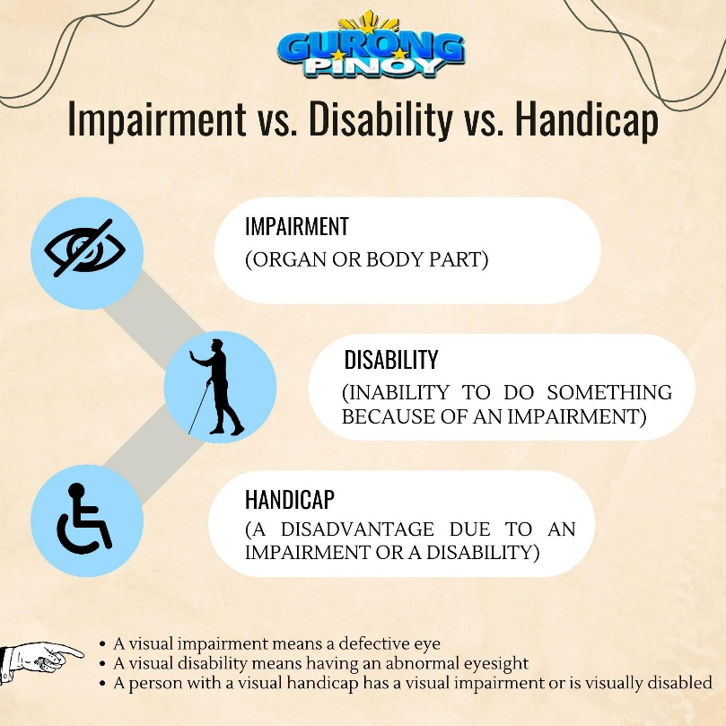
3. What is the concept that refers to the reduced function or loss of a specific part of the body?
- Impairment
- Disability
- Handicap
- Weakness

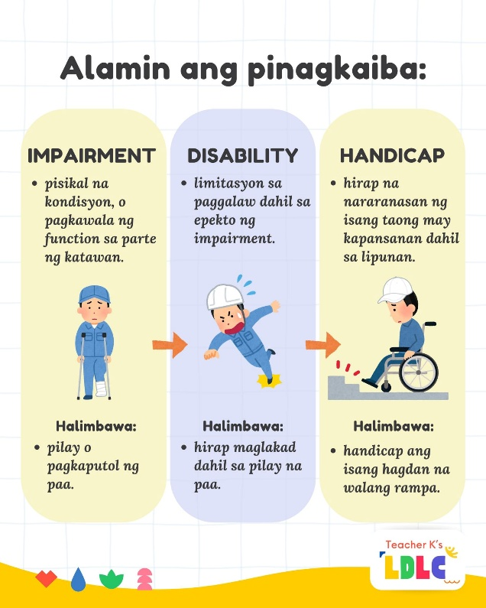

Note: Differences of Impairment, disability, handicap

IMPAIRMENT: Specific body part

DISABILITY: Inability to do something

HANDICAP: Disadvantage due to an impairment or disability

4. What is the practice of placing learners in a regular class based on their age, regardless of their abilities or disabilities?
- Normalization
- Mainstreaming
- Integration
- Inclusion

NOTE: Different classroom practice

NORMALIZATION: Living conditions as normal as possible

MAINSTREAMING: partial placement in regular class

INCLUSIVE: combining groups but not fully inclusive

INCLUSION: placing learners in a regular class based on their age, regardless of their abilities or disabilities

5. What are the three categories of 21st Century skills?
- Information literacy, Media literacy, Technology literacy
- Critical thinking, Creativity, Collaboration
- Flexibility, Leadership, Initiative
- Learning skills, Literacy skills, Life skills

Note: 21st century skills (LLL)
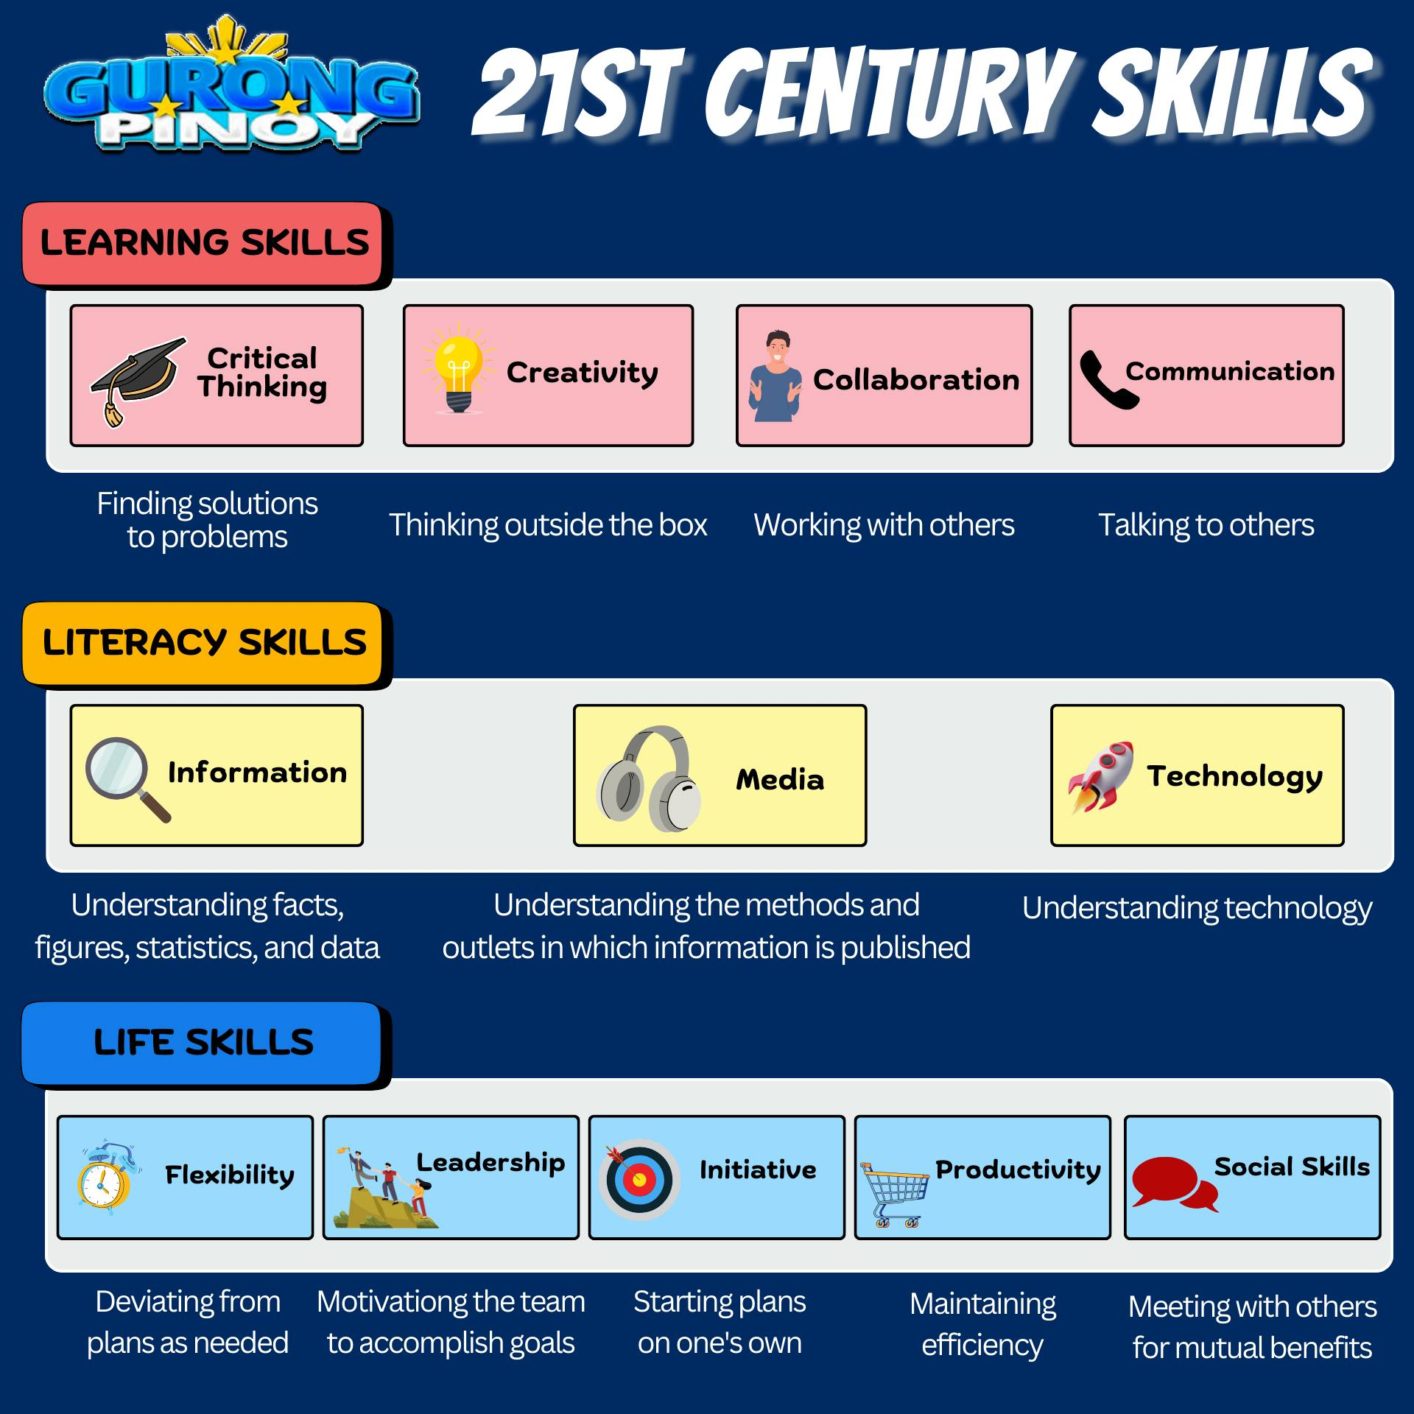

LEARNING SKILLS | LITERACY SKILLS | LIFE SKILLS
- Critical thinking  - Creativity  - Collaboration  - Communication | - Information  - Media  - Technology | - Flexibility  - Leadership  - Initiative  - Productivity  - Social Skills

6. According to UNESCO, what is Inclusive Education (IE) about?
- Limiting the presence of learners
- Excluding learners with diverse needs
- Respecting learners' diverse needs, abilities, and characteristics
- Discriminating against learners in the learning environment

7. In the context of the Theory of Multiple Intelligence, which is a weakness of the paper-pencil test?
- It puts non-linguistically intelligent at a disadvantage.
- It is not easy to administer.
- It utilizes so much time.
- It lacks reliability.

8. Which term refers to the collection of students' products and accomplishments in a given period for evaluation purposes?
- Diary
- Portfolio
- Anecdotal record
- Observation report

Notes:

DIARY: personal reflections

PORTFOLIO: collection of students' products and accomplishments

ANECDOTAL RECORD: teacher observations

OBSERVATION REPORT: behavior notes

9. When a baby realized that a rubber duck which has fallen out of the tub must be somewhere on the floor, he is likely to achieve what aspect of cognitive development?
- Object permanence
- Deferred imitation
- Mental combinations
- Goal-directed behavior

Notes:

DEFERRED IMITATION: copying later

MENTAL COMBINATIONS: internal problem-solving

GOAL-DIRECTED BEHAVIOR: intentional actions

10. Which of the following is the correct order of psychosexual stages proposed by Sigmund Freud?
- Oral stage, anal stage, phallic stage, latency stage, genital stage
- Anal stage, oral stage, phallic stage, latency stage, genital stage
- Oral stage, anal stage, genital stage, latency stage, phallic stage
- Anal stage, oral stage, genital stage, latency stage, phallic stage

OEDIPUS (boy) AND ELECTRA (girl) COMPLEXES: children experience unconscious sexual desires for the opposite-sex parent and view the same-sex parent as a rival.

11. When a little girl who says she wants her mother to go on vacation so that she can marry her father, Freud believes that she is voicing a fantasy consistent with?
- Oedipus complex
- Electra complex
- Theory of mind
- Crisis of initiative vs. Guilt

12. What stage of Piaget's Cognitive Development does a person belong to when he can understand specific logical ideas and apply them to concrete problems?
- Preoperational thought
- Operational thought
- Concrete operational thought
- Formal operational thought

Note: Smart People Cook Fish
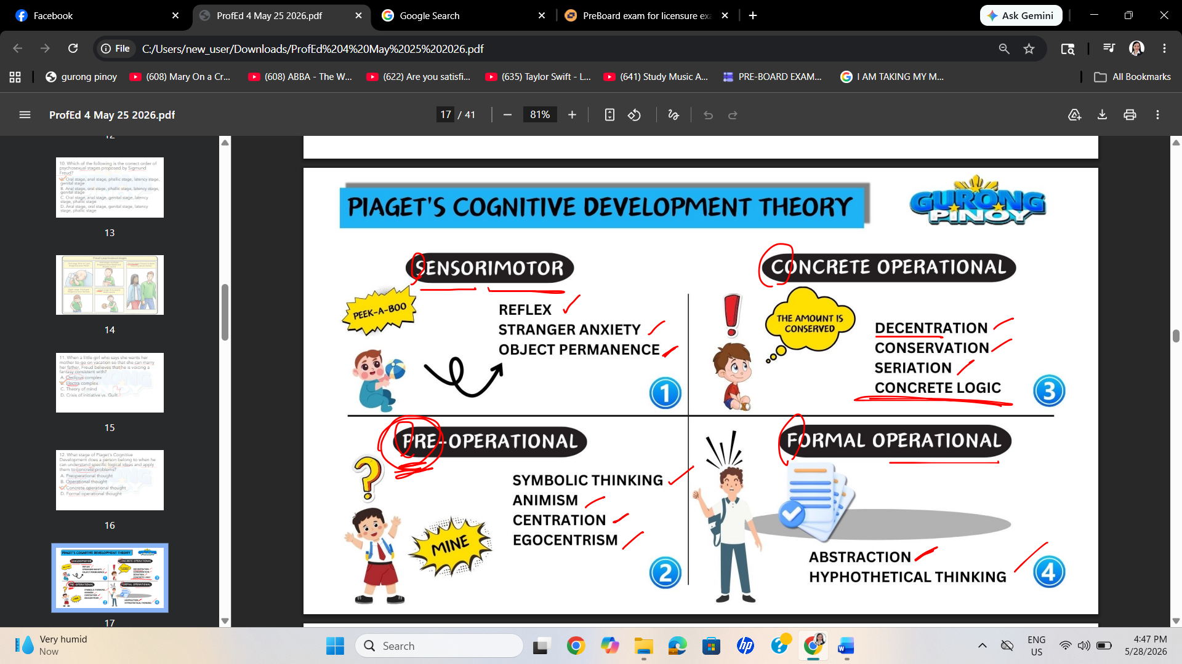

REFLEX: Innate abilities

PRE- OPERATIONAL: preschoolers

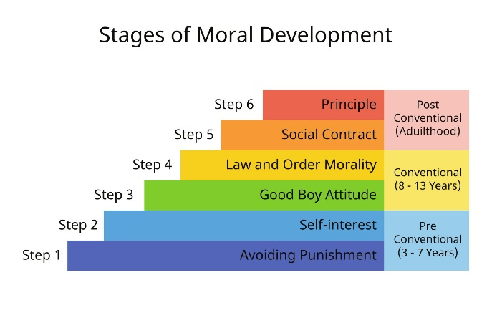
13. According to Kohlberg, a dutiful citizen who obeys the laws set down by society is at which level of moral reasoning?
- Pre-conventional Stage One
- Pre-conventional Stage Two
- Conventional
- Post-conventional

14. Among approaches to child development, which is the basis for Spanish friars in religious schools using the stick to punish children who misbehave in class?
- Classical conditioning
- Social cognitive learning
- Socio cultural learning
- Operant conditioning

Note:

CLASSICAL: Association

SOCIAL COGNITIVE: observation/ modelling

SOCIO-CULTURAL LEARNING: learning through culture/ social interaction

OPERANT CONDITIONING: reward and punishment

15. What is the objective of routines for class management?
- To reward performers
- To ensure order
- To eliminate stress
- To punish offenders

16. What does a difficulty index of 1 mean? The test item is _______.
- not valid
- not reliable
- very easy
- difficult

Note: The DIFFICULTY INDEX measures the percentage of students who answered a question correctly. It ranges from 0.00 to 1.00.
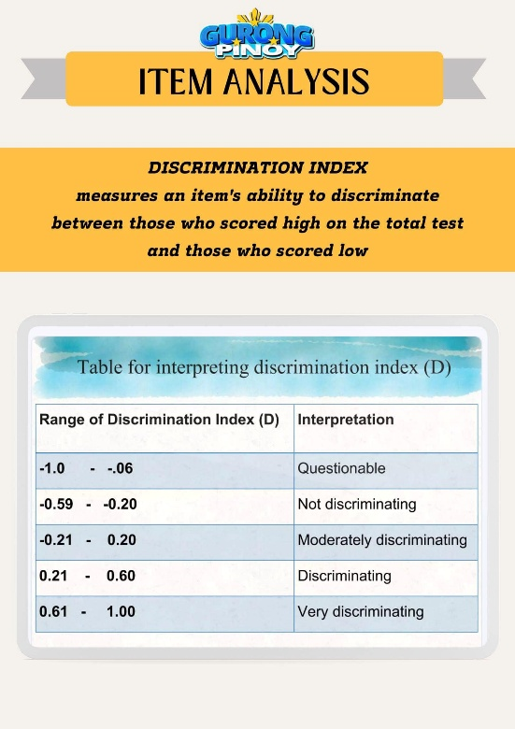
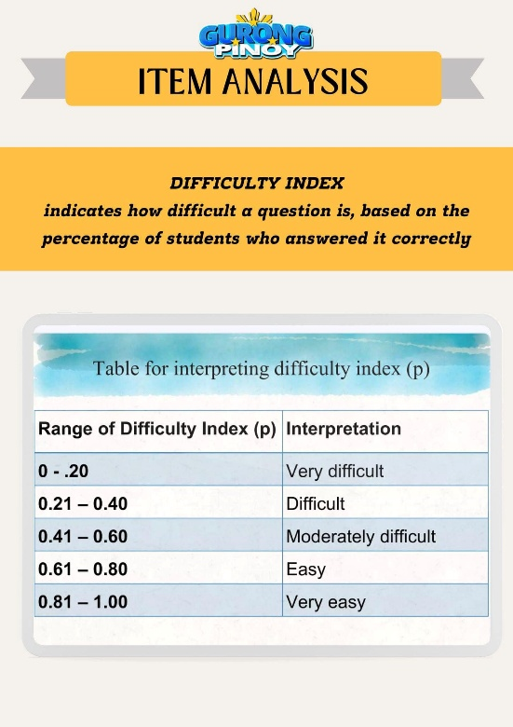

17. These are examples of scaffolds that the teacher can use to facilitate learning especially for those who falter or fail behind in class discussions, but NOT to include -
- Questions
- Cues
- Drills
- Prompts

18. To what pillar of learning does collaborative project-making belong?
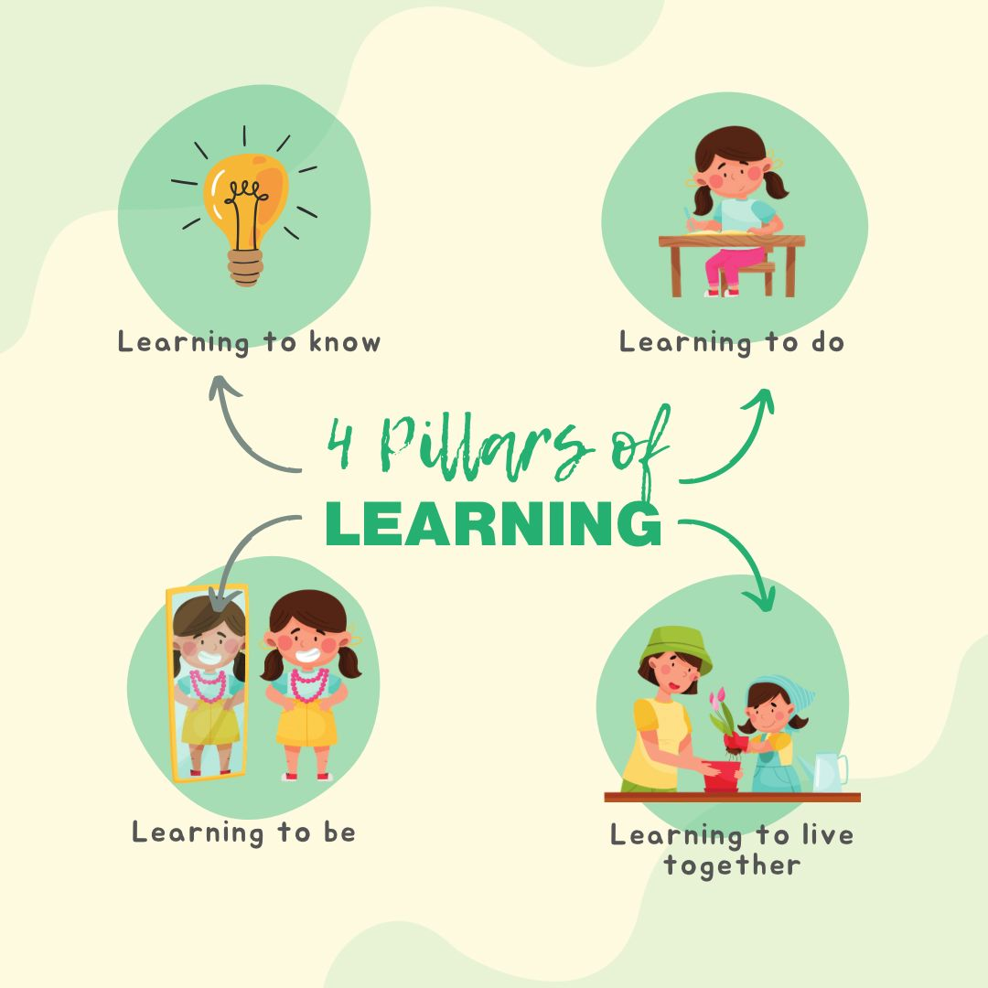
  - Learning to know
  - Learning to live together
  - Learning to be
  - Learning to do

Note:
KNOW = mind

DO = skills/competencies

BE = self-actualization

LIVE TOGETHER = values

TRANSFORM = flexibility/resilience

19. According to Robert Gagne's sequencing, which should be the first step in planning instruction?
- Plan to motivate
- Test instruction
- Specify context
- Identify learning outcomes
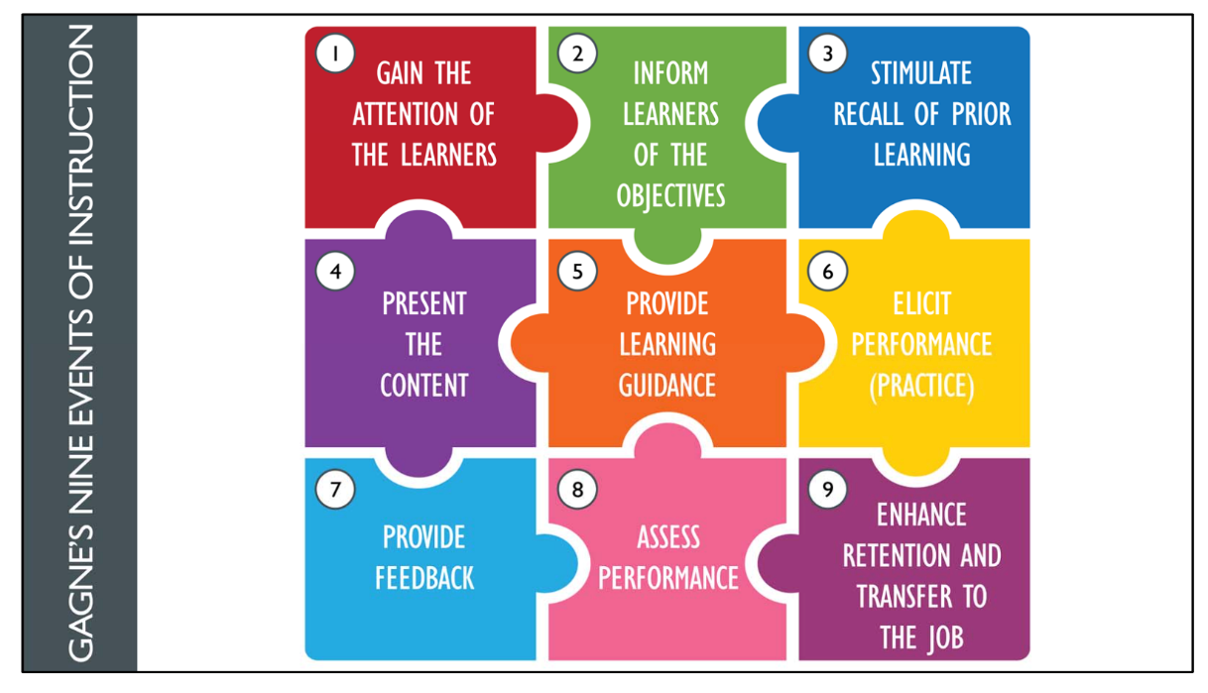

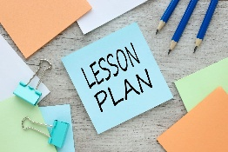


NINE EVENTS OF INSTRUCTION
Robert Gagne
(Systematic step-by-step approach to
help educators structure lessons)

20. What kind of assessment uses a checklist, portfolio rubrics or a rating scale?
- Informal assessment
- Authentic assessment
- Placement assessment
- Alternative assessment

21. How do you classify objective 'To identify the parts of the flower' in terms of Bloom's taxonomy of educational objectives at the cognitive level?
- Analysis
- Knowledge
- Application
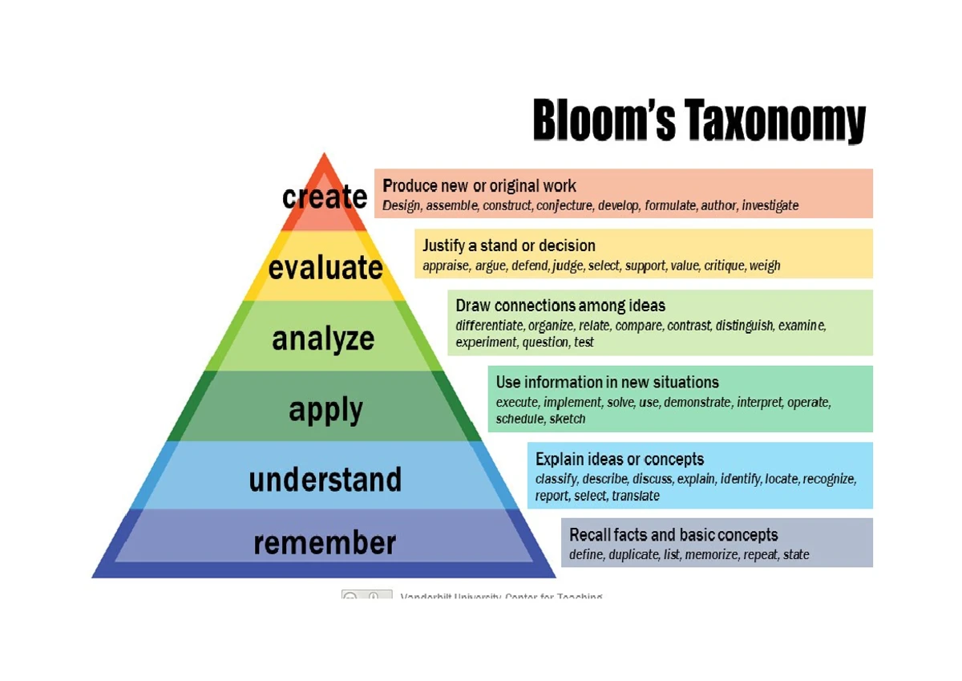
- Synthesis



TAXONOMY OF EDUCATIONAL
OBJECTIVES (original)
Benjamin Bloom
(KKAASE)


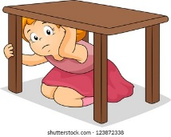
TAXONOMY OF EDUCATIONAL
OBJECTIVES (revised)
Lorin Anderson
(RUAAEC)

22. On learning deficiencies, what is learning disability in reading?
- Dyslexia
- Dyscalculia
- Dysgraphia
- Dyspraxia

Note:

DYSLEXIA: difficulty in reading

DYSCALCULIA: Math difficulty

DYSGRAPHIA: writing difficulty

DYSPRAXIA: movement/coordination difficulty

23. In Bandura's social learning theory, what is self-control over one's functioning and over events, such when students maintain their honor grades?
- Creativity
- Efficiency
- Innovation
- Self-efficacy

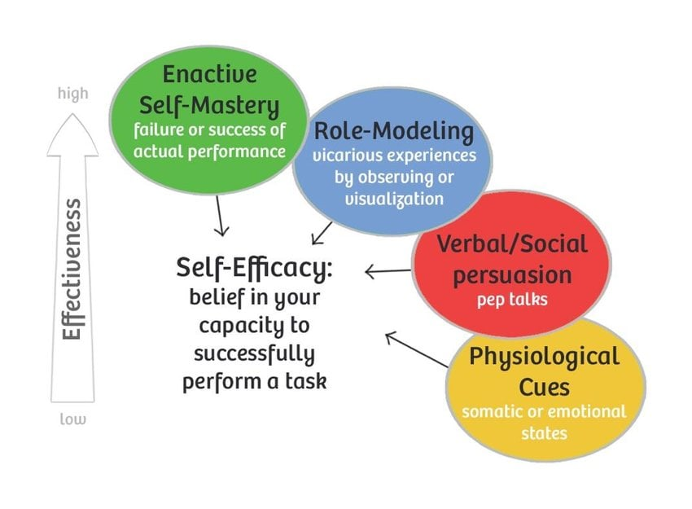

23. In Bandura's social learning theory, what is self-control over one's functioning and over events, such when students maintain their honor grades?
- Creativity
- Efficiency
- Innovation
- Self-efficacy

24. Which exemplifies differentiated instruction directed at heterogeneous groups in a class?
- Same task for all groups
- Different tasks, appropriate for each group
- Three different teachers to assess groups
- Divide class, same tasks

25. What level of the cognitive process is required in writing an essay on the personality of a fellow classmate?
- Recalling
- Creating
- Analyzing
- Applying

26. Considering the percentage contribution to the grades for Grades 1-10, what can you infer from DepEd’s emphasis on learning and assessment?
- The emphasis is on quarterly assessment.
- All components are equally emphasized.
- The emphasis depends on the grade level.
- The emphasis for all Grade 1 to 10 is on performance tasks.

27. Which of these is not a routinized activity necessary for efficient classroom management?
- Group presentations
- Distribution of worksheets
- Grouping of students
- Passing of papers

28. Based on DepEd’s grading system, which assessment is/are used to determine the grades of students?
I. Formative assessment
II. Summative assessment
III. Assessment of learning
- I only
- I and III
- I and II
- II and III

29. The following are the physical products for assessment EXCEPT for ____.
- Sculpture
- PowerPoint presentation
- Essay
- Photographs

30. Jun-Jun does not realize that the juice in each glass can be poured back into the juice box where it came from. Jun-Jun demonstrates
- Egocentrism
- Reversibility problem
- Lack of object permanence
- Seriation problem

